**6.05.2025 (Tuesday), 12:00**

Department of Archaeology and Museum Studies, Taras Shevchenko National University of Kyiv

Institute of Archaeology of the NAS of Ukraine

VENUE: Main building of Taras Shevchenko National University of Kyiv,

Faculty of History, Room 349, 12:00

**SCIENTIFIC COLLOQUIUM**

**ART AS SOCIAL BEHAVIOUR: ORNAMENTATION IN PREHISTORIC CULTURES**

Prof. Dr. Wulf Schiefenhövel

Max Planck Institute for Biological Intelligence

**Art as behaviour**

Dr. Marian Vanhaeren

Centre National de la Recherche Scientifique in France

**From the geographical distribution of beads to Early Upper Palaeolithic ethnocultural geographies**

Dr. Marian Vanhaeren

Centre National de la Recherche Scientifique in France

**Interpreting personal ornaments found in Upper Palaeolithic child burials: the case of La Madeleine (Dordogne, France), Grotta dei Fancuilli (Liguria, Italy) & Lagar Velho (Center Region, Portugal)**

Dr. Nataliia Mykhailova

Institute of Archaeology the National Academy of Sciences of Ukraine

**Personal ornaments of the Neolithic Mariupol type cemeteries**

Dr. Alina Stupak

National Natural History Museum of Ukraine

**Zoomorphic figurine from Neolithic site Vovnyhy of Surska culture**

Prof. Dr. Wulf Schiefenhövel

Max Planck Institute for Biological Intelligence

**Modern models of the past — The Eipo, a Papuan Group in the Star Mountains of West-New Guinea**

**ABSTRACTS**

**Prof. Dr. Wulf Schiefenhövel**

**Art as behaviour**

In disciplines like art history, sociology, philosophy and also in the general public, a phrase has dominated and is dominating the discussion of art: "Art is in the eye of the beholder!", in other words, there are no cross-individual, universal criteria what is (particularly in the visual arts) beautiful and what is not. The dictum seems so obvious and clear that it usually kills any counter argument. But, regarding the evolved physiology and neurobiology of visual perception, it is totally wrong. Our retina is only the first receptor in the long cerebral cascade of transforming, analysing and, at the end, interpreting the visual stimulus perceived by the eyes. Bower Birds, relatives of the birds of paradise and likewise at home in New Guinea and Australia, are among the very few species and indeed the masters of creating, like humans, extra-corporal beauty. Their carpets of colourful flowers, fruits, stones etc. are not only attractive to the females of their species, but also for us, humans with a totally different evolutionary history. Obviously, there are templates in ours and their brain, which create the impression of beauty. In the same way, we humans are attracted and touched by the songs of many of the birds, produced in a totally different way than our own voice. The ability to perceive beauty is, one can thus deduct, deeply embedded in the phylogeny of animals - as is, as Charles Darwin has convincingly shown, the capacity for emotional assessment and subsequent signalling to others via facial expression. I will present visual art from Mainland and Island New Guinea, as well as oral art, especially lyric of songs of mourning, when one has lost a beloved person, and of romantic love, which is, again in contrast to long-held convictions in the arts and humanities, no consequence of the Renaissance, but a powerful emotion, triggered by hormones and transmitter substances, common to all of us on the planet, today and in prehistory. The evolutionary approach to discussing art focusses, in a radically different way than that in the feuilletons and galleries of our times, on the act of making it, especially its psycho-social power and thereby its function in primordial and modern society. To be able to create art must have been a decisive individual and thereby selected advantage from the begin of our genus on. It can and should, therefore, be discussed in evolutionary, not only sociological terms.

**Dr. Marian Vanhaeren**

**From the geographical distribution of beads to Early Upper Palaeolithic ethnocultural geographies**

Our understanding of how the first modern humans migrated into Europe at the start of the Upper Palaeolithic is still unclear. We don’t know much about their biological, linguistic, and cultural diversity, or how they interacted with local Neanderthals. However, studies show that personal ornaments found in archaeological sites can reveal a lot about different human groups. The types of beads used and their specific arrangements can indicate ethnic differences. We would expect these variations to be visible in the archaeological findings. To investigate this further, we looked at 157 types of beads across 98 Aurignacian sites in Europe. By analyzing this data, we found a clear pattern: there is a directional gradation of bead types moving counter-clockwise from the Northern Plains to the Eastern Alps, passing through Western and Southern Europe. We identified 14 groups of sites that are geographically connected. The most diverse groups include sites in the Rhône valley, Italy, Greece, and Austria on one side, and Northern European sites on the other. Notably, these two broad groups do not share any bead types, each having unique styles but sharing some common ornaments with the middle group of sites in Western France, Spain, and Southern France. We believe this pattern indicates the ethnic and linguistic diversity of the earliest Upper Palaeolithic populations in Europe, which cannot be explained simply by the age of the sites or the availability of materials.

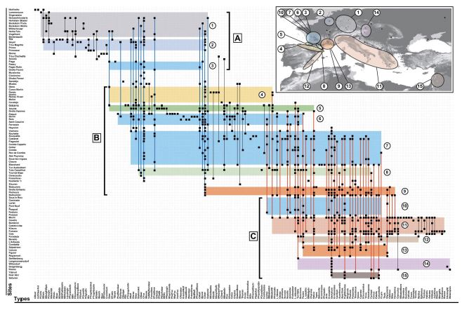

**Dr. Marian Vanhaeren**

**Interpreting personal ornaments found in Upper Palaeolithic child burials: the case of La Madeleine (Dordogne, France), Grotta dei Fancuilli (Liguria, Italy) & Lagar Velho (Center Region, Portugal)**

Personal ornaments can offer rich and varied information on prehistoric individuals and societies. As clothing accessories, they can give clues as how prehistoric outfit looked. As symbolic objects they can give insights into the social organization and exchange networks. Well preserved undisturbed primary burials with durable decorative items still in place offer unique opportunities to investigate these aspects. Here we present three case studies of Upper Palaeolithic primary child burials from Western Europe. The c. 2-4 years old La Madeleine child was discovered in 1926 in the eponymous site of the Magdalenian in the southwestern France and directly dated to 10 190 ± 100 BP. It was buried with up to 10 different bead types Among them 2 red deer canines, 2 fox canines, 1 perforated phalange of a rabbit or hare, 1 fish vertebra, 1 *Glycymeris*-, 36 *Turitella*-, 20 *Cyclope*-, 160 *Neritina*-, and, most spectacular in number, 1314 *Dentalium* shells. The double child burial of the Grotta dei Fanciulli was discovered 1874-1875 in Liguria, Italy and directly dated to c. 11,130±100 BP. These children of 1-2 and 2-4 years old were buried with more than 1000 *Cyclope* shells and some other shells as well as two distal phalanges of red deer. A flint point in one of the child’s thoracic vertebra suggests a violent death. The c. 4 year old Lagar Velho child, directly dated to 23,950 ± 150 B.P, was discovered in the Centre region of Portugal in 1998 with four red deer canines and two *Littorina obtusata* marine shells. Archaeozoological-, taphonomical-, morphometrical-, technological- and use-wear analyses as well as the creation of natural and experimental reference collections allows to interpret the La Madeleine child personal ornaments as a miniature version of adult beads, a testimony of most likely parental love and care, and perhaps also of a special hereditary social status. The same may be true for the two children of the Grotta dei Fanciulli. The Lagar Velho child most likely did not display miniature versions but the same ornaments as adults. The specific characteristics of the red deer canines allow to suggest a symbolic connotation as representing unity of the society as whole.

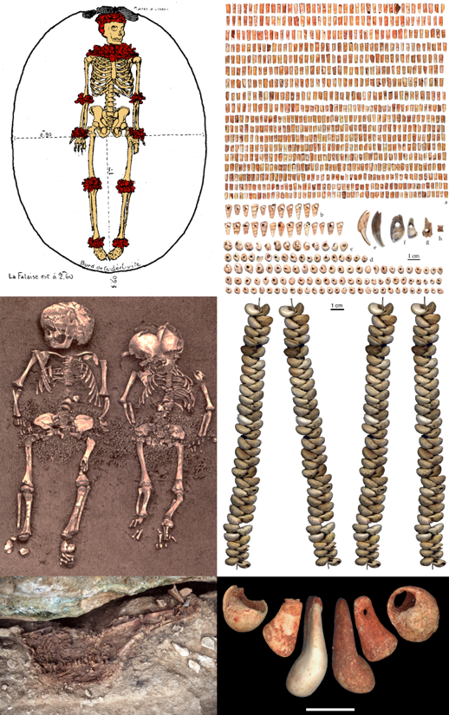

**Dr. Nataliia Mykhailova**

**Personal ornaments of the Neolithic Mariupol type cemeteries**

Mariupol type сemeteries of late Mesolithic – Neolithic, located from the Prut-Dniester interfluve to the Don River, mostly located along the Lower Dnipro rapids, distinguish by their rich burial inventory, mostly, elaborated adornments. Personal ornaments, which marked the semantically important parts of the bodies of the buried, could be evidence of a spiritual culture (a shaman’s attributes), a sign оf regional identity or marker of a clan or ancestral affiliation, gender-age differentiation or biological stage of human development.

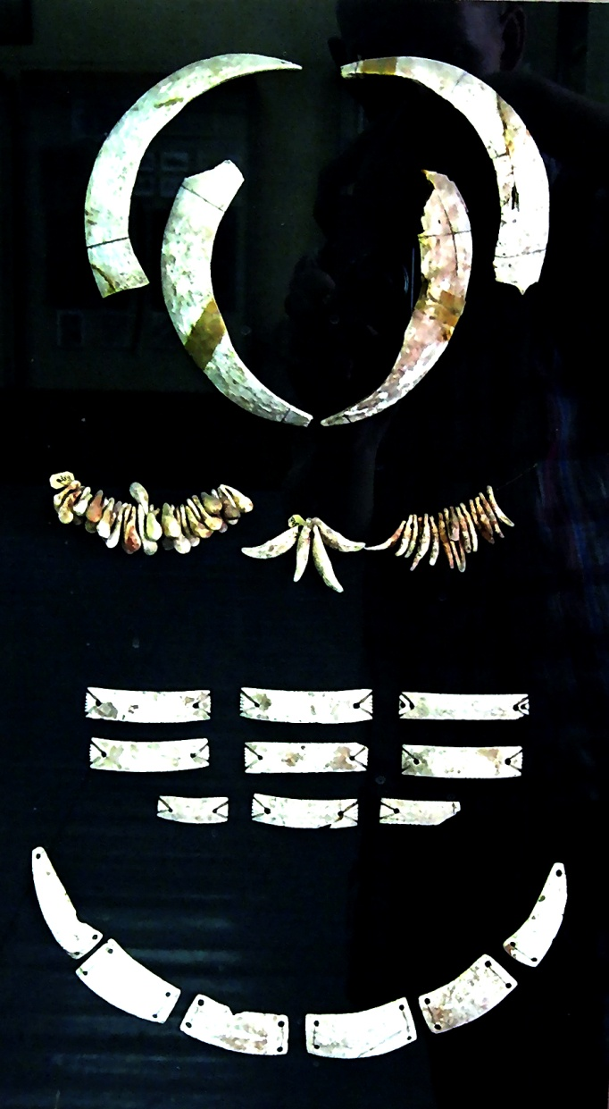

**Prof. Dr. Wulf Schiefenhövel**

**Modern models of the past — The Eipo, a Papuan Group in the Star Mountains of West-New Guinea**

In recent decades, archaeological research has made impressive advances in analysing and interpreting findings from excavations. It is, however, still true, that objects don't speak. How the respective prehistoric people actually felt, thought, behaved and spoke can therefore only be assessed in approximate ways. Ethnography and Ethnoarchaeology can offer solutions to this heuristic problem. Evolutionary anthropologists have primarily focussed on societies with subsistence strategies of hunting-gathering-utilising aquatic resources, as these determined the livelihood of pre-agricultural populations. The relatively few societies of this kind were very rare and have basically disappeared by now. Several societies with traditional "neolithic" ways of life, on the other hand, have survived until the end of the last millennium. The Eipo, members of the Mek group of cultures and languages in the Star Mountains of West- (Indonesian) New Guinea had, at the begin of interdisciplinary research in 1974, an exclusively neolithic tool kit of stones, bones, teeth and wood. The social structure of these small groups of horticulturists and pig breeders was quite comparable to that of those common in prehistoric times. Their knowledge of the outside world was 3-4 days walking, their religion and social customs were still intact. How the Eipo managed to not only survive in their alpine environment between 1,700 to 3,500 m above sea-level, but build an impressive culture of complex language, rich oral history, fantastic botanical and zoological knowledge, and, above all, a well-functioning social life is subject of my research since the onset of the project "Humans, Culture and Environment in the Central Mountains of West-New Guinea". Conclusions from insights over 51 years of work among and with the Eipo can shed light on archaeological issues, otherwise difficult to fathom.

**Dr. Marian Vanhaeren** studied archaeology at the University of Leuven in Belgium and the University of Bordeaux in France where she defended her PhD (2002) on the topic of Upper Palaeolithic personal ornaments. After post-doctoral positions in Paris (CNRS) and London (University College) she became a researcher at the Centre National de la Recherche Scientifique in France. She participated in the study and publication of ancient personal ornaments from Africa, Europe, Asia and South America. Her research focuses on the characterisation of prehistoric societies, in particular their social organisation, exchange systems and ethno-cultural units. She uses modern, fossil, experimental and ethnographic reference collections, taphonomic, technological, morphometric and use-wear analyses, microscopy, macrophotography, GIS, descriptive and multivariate statistical analyses for the study of prehistoric personal ornaments. Since 2013 she has been increasingly involved with archaeological and ethno-archaeological research in the Papuan Provinces. She published 1 book and about 100 articles.

**Prof. Dr. Wulf Schiefenhövel** is Head of the Human Ethology Group at the Max Planck Institute for Biological Intelligence in Seewiesen (Germany). He studied medicine in Munich and Erlangen (PhD 1970), defended his habilitation for Medical Psychology and Ethnomedicine in 1984, and got a professorship in 1991 at the University of Munich. He is guest professor for Human Ethology at the University of Innsbruck since 1990 and co-founder of ethnomedicine in Germany, conducts fieldstudies in ethnomedicine, anthropology and human ethology in Melanesia since 1965, especially, since 1974, among the Eipo, a Highland Papuan group of the Mek cultures and languages in Indonesian New Guinea. He has been fellow  at Wissenschaftskolleg Berlin, Centre for Interdisciplinary Studies Bielefeld, Collegium Budapest and Hanse Centre for Advanced Study Delmenhorst and served as president of the German Societies for Ethnomedicine and for Anthropology as well as for the International Society for Human Ethology. His research fields include human ethology, evolutionary anthropology, evolutionary medicine, language and cognition, anthropology of food, ethnomedicine, medical anthropology, population genetics and history of human dispersal in Melanesia. He authored, coauthored, edited, coedited 30 books and over 400 publications.

**Dr. Nataliia Mykhailova** is Senior Researcher at the Institute of Archaeology of the National Academy of Sciences of Ukraine. Her research interests include the spiritual culture and art of primitive societies in Eurasia. Synthesizing ethnographic and archaeological sources, including rock and mobile art, she creates a reconstruction of the worldview of Stone Age hunters. Recent research has focused on the interpretation of material manifestations of rituals (burial complexes and sanctuaries) at Ukrainian sites in comparison with materials from Europe and North Asia. Member of WAC, EAA, SAA. She is the author of more than 60 scientific articles, published in Ukraine, USA, Italy, Sweden, Romania, Germany, Lithuania, Moldova and Japan.

**Dr. Alina Stupak** is an archaeozoologist and a member of the Palaeontology Department of the National Museum of Natural History of the National Academy of Sciences of Ukraine. She studies the remains of animals, primarily mammals, from archaeological sites. Her area of interest is the Stone Age periods — the Paleolithic, Mesolithic, and Neolithic. She also has projects related to other periods. An additional interest is the history of paleontology in Ukraine, particularly in women in paleontological research. Research results are published on the ResearchGate platform, and popular science videos are posted on the museum's YouTube channel.